**Exp No:** 12 **Date:** 01/11/2020

**Name:** Swetha Saseendran

**Reg No:** 185001183

8-BIT ARITHMETIC OPERATIONS USING 8051

## Aim:

To program and execute 8-bit arithmetic operations using 8051 microcontrollers using EDSim.

# Programs:

# (i) 8-BIT ADDITION

## Algorithm:

* Move input1 to A.
* Add the second input to A and store the result in A.
* Jump if no carry to label.
* Increment register 0.
* Label: mov the result to register 4 and carry to register 3.
* Here: short jump here.

|  |  |
| --- | --- |
| **Program** | **Comment** |
| ;Program to subtract 2 8 bit numbers using 8051 microcontroller  MOV R0, #00  MOV A, r1  ADD A, r2  JNC LABEL  INC R0  **LABEL:** MOV r4, a  MOV 03, R0 ;(mov r3, r0 is invalid)  **HERE:** SJMP HERE | Move value 00 to R0.  Move input1 to A  Add A and 2nd input and store in A  Jump if no carry to label  Increment R0  Move result to R4  Move carry to R3  End |

# Snapshot of sample input and output:

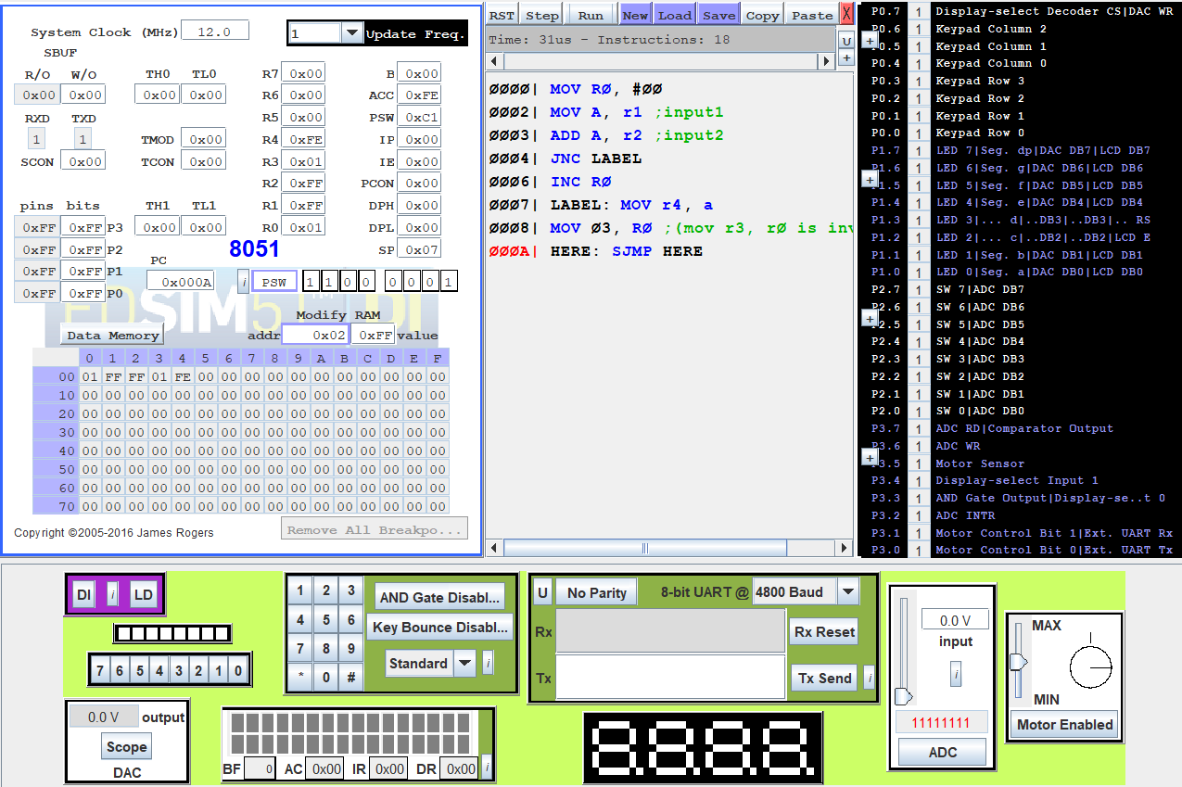

# (ii) 8-BIT SUBTRACTION

## Algorithm:

* Move input1 to A.
* Add the second input to A and store the result in A.
* Jump if no carry to label.
* Increment register 0.
* Label: mov the result to register 4 and carry to register 3.
* Here: short jump here.

|  |  |
| --- | --- |
| Program | Comment |
| ;Program to subtract 2 8 bit numbers using 8051 microcontroller  MOV R0, #00  MOV A, r1  SUBB A, r2  JNC LABEL  CPL A  INC A  INC R0  LABEL: MOV r4, A  MOV 03, R0  **HERE:** SJMP HERE | Move value 00 to R0.  Move input1 to A  Subtract A and 2nd input and store in A  Jump if no carry to label  complement A  Increment A  Increment R0  Move result to R4  Move carry to R3  End |

# Snapshot of sample input and output:

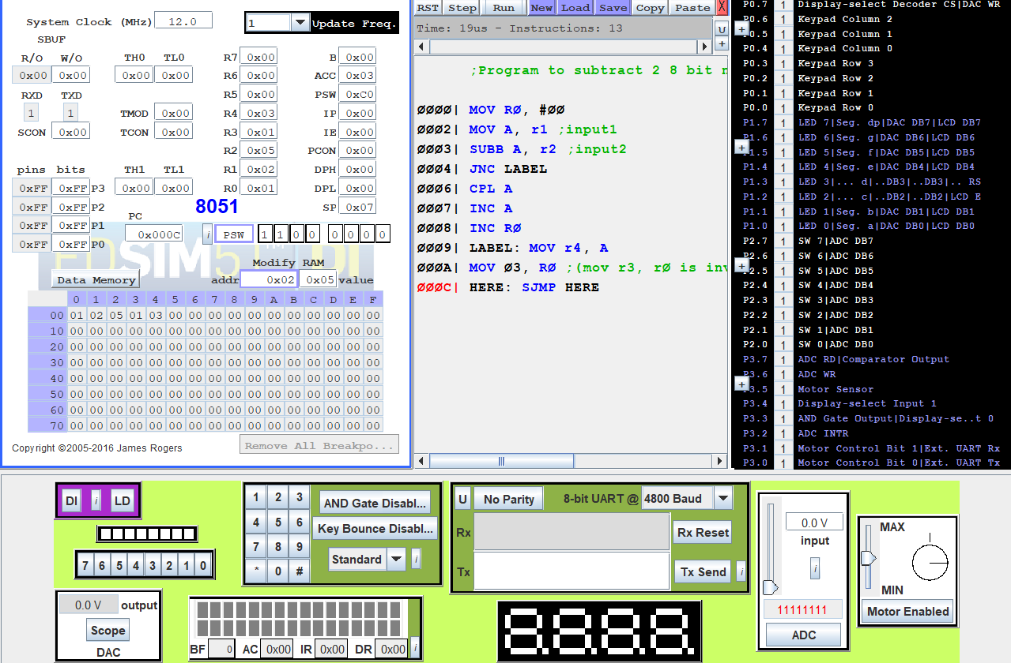

### (iii) 8-BIT MULTIPLICATION

## Algorithm:

* Initialize R0 with 00h
* Move the value in R1 to A.
* Move the value in R2 to B.
* Multiply A and B.
* Move B to R4 (MSB of product) and A to R5 (LSB of product)

|  |  |
| --- | --- |
| **PROGRAM** | **COMMENTS** |
| MOV R0, #00 | R0 has address of 0x00 |
| MOV A, R1 | 0x01 has 1st 8-bit number |
| MOV B, R2 | 0x02 has 2nd 8-bit number |
| MUL AB | BA = A * B |
| MOV R5, A | Move lower byte to R5 from A |
| MOV R4, B | Move higher byte to R4 from B |
| **HALT:** |  |
| SJMP HALT | Halt the program with a loop. |

## Snapshot of sample input and output:

### (iv) 8-BIT DIVISION

## Algorithm:

* Initialize R0 with 00h.
* Move the value in R1 to A.
* Move the value in R2 to B.
* Divide A by B.
* Move A to R4 (Quotient) and B to R5 (Remainder)

|  |  |
| --- | --- |
| **PROGRAM** | **COMMENTS** |
| MOV R0, #00 | R0 has address of 0x00 |
| MOV A, R1 | 0x01 has 1st 8-bit number |
| MOV B, R2 | 0x02 has 2nd 8-bit number |
| DIV AB | BA = A / B, A: Quotient, B: Remainder |
| MOV R5, A | Move quotient to R4 from A |
| MOV R4, B | Move remainder to R5 from B |
| **HALT:** |  |
| SJMP HALT | Halt the program with a loop. |

## Snapshot of sample input and output

# Result:

The assembly level programs were written to perform the above specified 8-bit arithmetic operations using an 8051 microcontroller and the outputs were verified.